# Inhalation toxicity of cinnamaldehyde: a route-to-route extrapolation PBK approach

# Introduction

An important public health act that shapes how such additives are used currently was the Food Additives Amendments to the Federal Food, Drug, and Cosmetic Act. This United States (US) act meant that each substance intentionally added to food in the US had to be pre cleared by the Federal Food and drug Authority (FDA). The GRAS program is run by The Flavor and Extract Manufactures Association of the United States (FEMA).

A decline in cigarette use has been noted by the WHO in almost all regions across the planet(WHO., 2021). This can be ascribed to a number of factors such as increased public awareness of the risk of health effects, due to the introduction of nicotine patches and by the rise of Electronic cigarettes (EC)(Hartmann-Boyce et al., 2021). With EC a consumer is no longer exposed to the burning of tabaco. EC work by the vaporization and inhalation of a blend of nicotine, propylene glycol and/or glycerol. Furthermore, EC mixtures are often enhanced further with the addition of flavoring agents (Omaiye et al., 2019; Page & Goniewicz, 2021). Examples of such flavoring agents are Vanillin (Vanila), Benzaldehyde (Almond) and Cinnamaldehyde (Cinnamon). CNMA is a Generally Regarded as Safe (GRAS) food additive. A GRAS food ingredient is having shown adequately through scientific procedures to be safe under the conditions of intended use. CNMA is an examples are of a subclass of reactive chemicals known as aldehydes. Aldehydes are compounds which possess a carbonyl group with a substituent Hydrogen atom (Lopachin & Gavin, 2014). These carbonyl groups are known for the electrophilic characteristics and associated reactivity. An assortment of aldehydes are associated with adverse health outcomes. These include the known cancer causing agents: Formaldehyde, Acrolein and Crotonaldehyde IARC Working Group on the Evaluation of Carcinogenic Risks to Humans., 2021). Cinnamaldehyde (CNMA) is present in multiple vape products at concentrations up to 343mg/ml with possible high retention after exposure. (Khachatoorian et al., 2022; Omaiye et al., 2019). CNMA is noted to induce toxicity in in vitro systems including oxidative stress, inflammatory response and reductions in cell viability (Behar et al., 2014; Bhattacharya et al., 2021; Clapp et al., 2017, 2019; Gerloff et al., 2017; Ka et al., 2003; Muthumalage et al., 2018)

A considerable part of the appeal of EC is removal of a host of toxic and carcinogenic compounds found in cigarette smoke. Yet, a mounting body of evidence suggest adverse health effects can be seen after use of EC (Chatham-Stephens et al., 2014; Effah et al., 2022; Hua & Talbot, 2016). The exact cause of these adverse health effects is as of yet unknown. The reactive aldehyde CNMA is an interesting possible candidate that might contribute to adverse health effects. Even though it is GRAS ingredient the main exposure pathway considered by FEMA evaluations is oral exposure. Inhalation exposure is not an exposure pathway that has to be considered even for volatile chemicals (Hallagan & Hall, 2009). In order to investigate the risk of adverse health effects occurring due to exposure to CNMA in EC liquids a Physiological based kinetics model will be used. The model in question is an oral exposure model for CNMA that was used to estimate the DNA adduct formation in the liver (Kiwamoto et al., 2016). The aim of this paper is the add inhalation exposure to this model and evaluate if inhalation exposure to CNMA can lead to CNMA concentration in the body that are expected to lead to adverse health effects.

# Methods

## Section 1: model structure

As the basis for an inhalation model of CNMA, a previously developed oral exposure model by Kiwamoto *et al* (Kiwamoto et al., 2016) was used. The base code used in this model was used together with the metabolic parameters. Physiological parameters, chemical parameters and the following compartments where changed. DNA adduct formation and CNMA-GSH metabolism in the small intestine where removed as they were shown by (Kiwamoto et al., 2016) to be negligible. Added to the model was an inhalation compartment. This compartment was coded as described in (Jongeneelen & Berge, 2011a). This involves inhalation into the lungs into an alveolar air compartment from which CNMA is absorbed into the blood and enters circulation. CNMA can also enter the alveolar air and be exhaled. The model was coded in R (version 4.1.1) and R Studio (version 1.4.1717) using the Rxode, ggplot2 and PKNCA, packages(Fidler et al., 2022). Model code and equations can be found in supplementary data 1: R code.

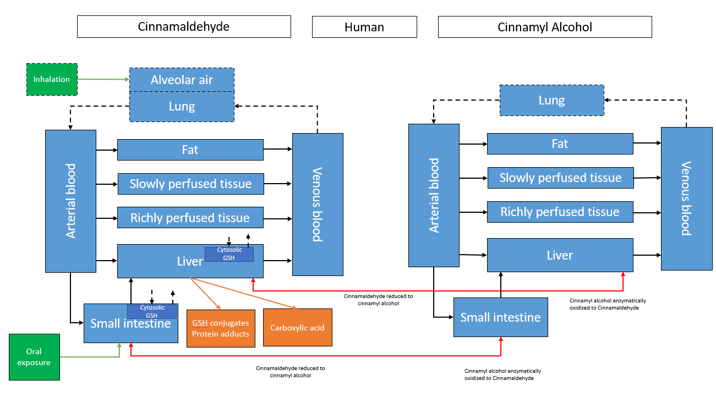

Figure : Structure of the inhalation CNMA model in Humans. Dotted lines represent additions to the model compared to Kiwamoto et al. Exposure routes are coloured green. Elimination routes are present in both the liver and small intestine and are coloured orange. In both the small intestine and the liver cytosolic Glutathione concentrations are modelled. Transformations of CNMA to Cinnamyl alcohol and back are represented by red lines.

## Section 2: Parameters

### Rat

The physiological parameters used for the rat model were adapted from Kiwamoto *et al*. Some parameters had minor changes. Details can be found in the supplementary data. Pulmonary parameters were based (Brown et al., 1997). The logKow was calculated using EPIsuite (Version 4.5 SP1).The partition coefficients where calculated based on this LogKow using both (Dejongh et al., 1997; Jongeneelen & Berge, 2011b). Kiwamoto *et al* also used Episuite and Dejongh *et al* to calculate the partition coefficients yet the values differ significantly. Sadly, Kiwomato *et al* provides no specifics as to how they were derived and thusly the reason for the difference is unexplained. The uptake constant Ka was calculated based on a method shown byYu et al,1999 (Yu & Amidon, 1999). The complete list of sources/calculations can be found in the supplementary data 2: parameters.

### Single Human model

The same approach was used with the the single human model as with the rat model. This means adopting the parameters as used by Kiwamoto *et al* and supplementing these parameters with additional parameters as needed. Pulmonary ventilation was derived from IRCP values (Alexaklrin Obninsk et al., 2003). Pulmonary blood flow as set as equal to cardiac output. The following parameters where calculated. Partition coefficients and the uptake rate constant. The LogKow values where calculated using EPIsuite (Version 4.5 SP1). Based on the LogKow the partition coefficients where calculated using both (Dejongh et al., 1997; Jongeneelen & Berge, 2011b). Similar unexplained differences in partition coefficients could be found as with rats. The uptake rate was calculated in the same way as in rat. The complete list of sources/calculations can be found in the supplementary data 2: parameters..

### Population based model

To more accurately model possible variation between individuals it was decided to create a population based model. As a basis for this model the following service was used. Popgen is a web based application which generates a population of individuals with necessary parameters for pbk modeling based on several initial parameters(Willmann et al., 2007). Using Popgen two data sets consisting of 1000 individuals were generated. One female data set and one male data set. To this data set the following parameters where added. Pulmonary ventilation (Alexaklrin Obninsk et al., 2003) the male value for the data set is based on a normal distribution and 3 standard deviations (99.7%) of variance based on the male mean of 540 L/h. the female value for the data set is based on a normal distribution and 3 standard deviations (99.7%) of variance based on the female mean of 390 L/h. Volume of arterial and venous blood. Blood compartment volumes were based on calculations shown in (Price et al., 2003). A complete overview of initial parameters and calculations can be found in the supplementary data 2: parameters.

## Model validation

As the PBK model used as the basis for the inhalation model is an oral absorption model validation of the inhalation component should be considered. Validation based on in vivo exposure data is the preferred method to do this. Unfortunately exceedingly little inhalation exposure data that is coupled with PBK relevant parameters is available (plasma concentration, tissue concentrations etc). Oral sensitization is an end point considered for human exposures. In order to bridge this gap a read across approach using the similar chemical Benzaldehyde was considered. Unfortunately, this chemical is similarly data poor. General performance of the model structure will be assessed based on the RAT models performance for oral exposure and human metabolic data.

## Exposure modeling

In order to create a plausible exposure scenario for use with the human models the limited date that is available on possible human exposure to CNMA from E-Cig liquids was used. (Khachatoorian et al., 2022) Exposure was modeled as being a 3 minute ‘smoke’ break using a E-Cig every 30 minutes for 6 hours. A total of 12 exposures. As Khachatorian *et al* (2022) has shown that the a E-Cig user consumes on average 567 mg of E-cig liquid per session. If we assume a worst case scenario with a CNMA concentration of 343 mg/ml (Omaiye et al., 2019) this would yield an exposure of 197.6 mg of CNMA per session. For an average person weighing this would yield approximately 2.8 mg/kg-BW.

## Section 3: Global sensitivity analysis

To evaluate the sensitive parameters of the models global sensitivity analyses where performed. This was done using a method demonstrated by Kasteel et al 2021 (Kasteel et al., 2021). This involves the `soboljansen` function from the Package `sensitivity´(Bertrand Iooss et al., 2022). This method requires the following input. Two data sets from which parameter values can be sampled for use in the analysis. These two data sets where generated based on the single human parameter set. As an upper bound the parameter values +1% and as a lower bound the parameter values -1% where used. Between these bounds the parameter values where normally distributed. The output of the analysis is a ranking of influential parameter using two indexes. The total effect and main effect. The total effects has cumulative value of 1 representing the contribution of a parameter to the overall change in output of interest. The main effect similarly has a cumulative value of 1 representing the contribution of this parameter independent of its effects on other parameters. The total and main effects for alle parameters where investigated at multiple time points for both oral and inhalation exposures. The corresponding code can be found in the supplementary data section 1: R code.

# Results

## Sensitivity analysis

Multiple global sensitivity analysis where performed for both the human and rat models. In rats the sensitive parameters determining the CNMA concentration in blood with oral and inhalation exposure were investigated. The results are presented in Figure 2 and Figure 3. During oral exposure the two most important parameters excluding T= 30 min where the uptake rate constant (Ka) and cardiac output (QC). At T=30 min the initial concentration of Gluthation in the liver (init_GSH_L) is the second most important parameters followed by the first order rate constant for the conjugation GSH with CNMA(k_L_GST). It can be noted that after 90 min the partition coefficient between air and blood for CNMA (PB) and pulmonary ventilation (PV) steadily increase in relevance. Body weight(BW) has a moderate impact at all time points. The sensitive parameters for inhalation exposure are noted to be considerably different. The two most important parameters are PB followed by BW. Both blood flow to Richly perfused tissue (Q_RP) and volume of slowly perfused tissue (V_SP) are moderately important at all time points. The sensitive parameters in the Human model where investigated using two different exposures . Firstly, a high dose of 250 mg/kg-BW to compare to the Rat model and secondly a 2.8mg/kg-BW dose comparable to a high E-Cig exposure dose. Secondly, we considered both the concentration of CNMA in blood and the concentration in lung If we consider the two different exposures. It can be noted that in both generally the same set of parameters is important. From these PB and PV are the most important parameters. Following in slightly different order are the following parameters; V_SP, Q_SP, Q_RP and V_Pu. Absent are parameters responsible for metabolic processes. This suggest that CNMA concentrations are dictated by perfusion dynamics.The sensitive parameters for oral exposure in Humans can be found in the supplementary data 3: supplementary graphs.

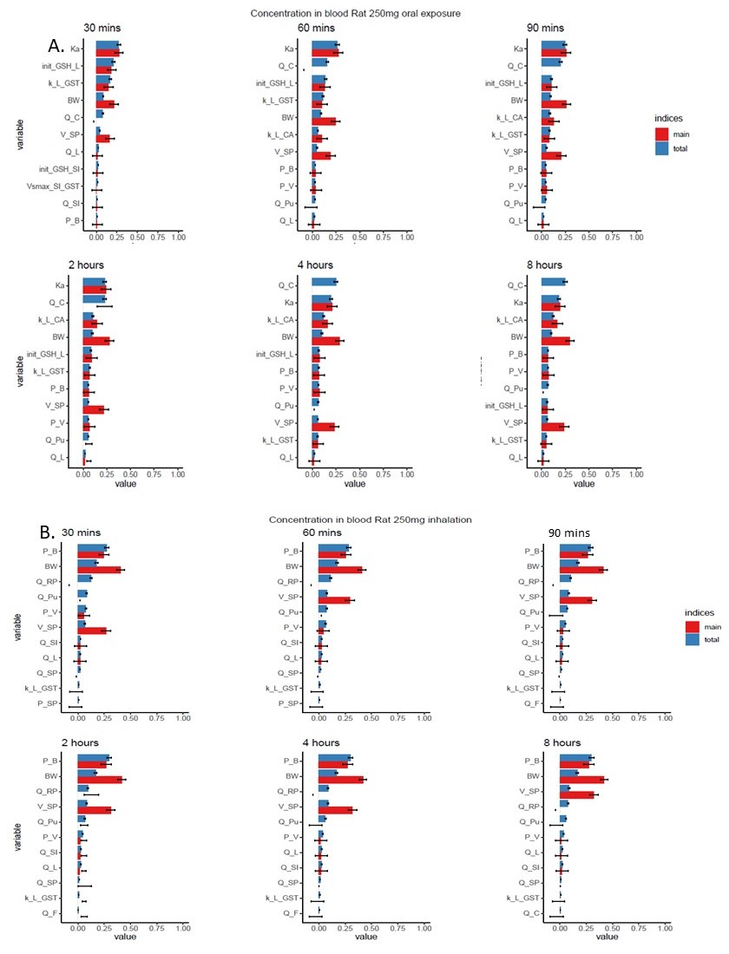

Figure : Global sensitivity analyses results for CINMA exposure both inhalation and oral in Rat 250 mg -kg/BW. (A) top ten sensitive parameters influencing the concentration of CNMA in the liver.

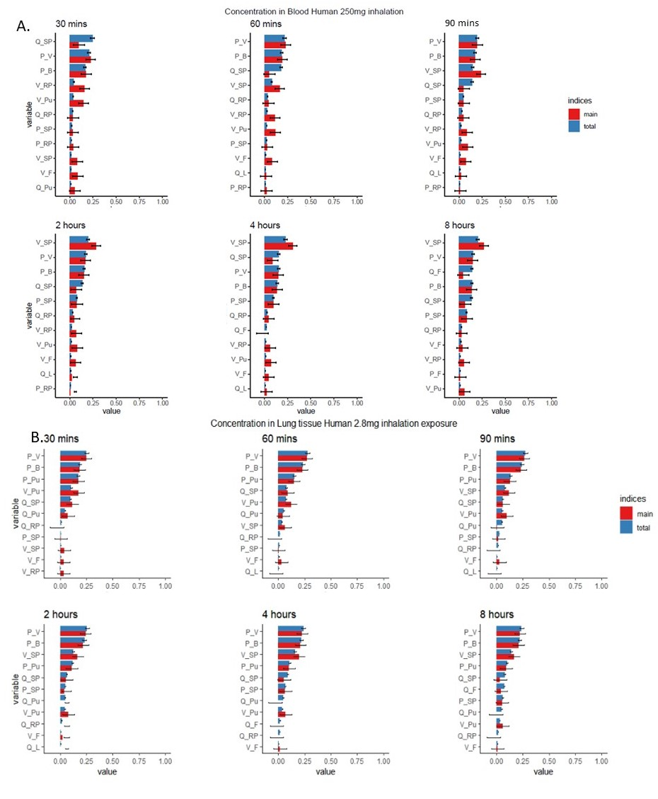

Figure : Global sensitivity analyses results for inhalation exposure with the human model. A; top ten sensitive parameters for inhalation exposure to a 250 mg/kg-BW dose. B; top ten sensitive parameters for inhalation exposure to a 2.8 mg/kg-BW dose.

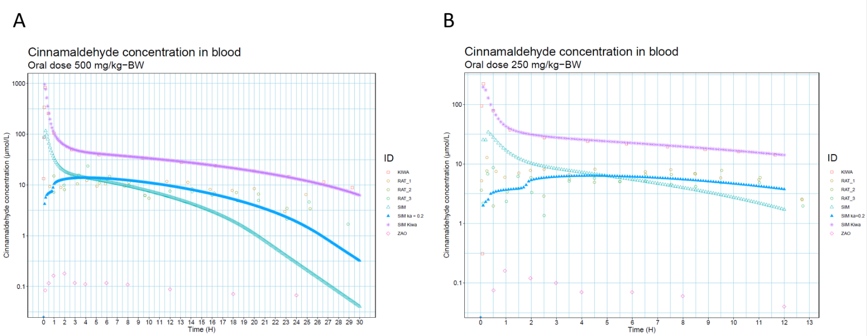

Figure : CNMA blood concentration comparison between simulated data and Kiwamoto. (🞏)The purple squares are the simulation data form Kiwamoto et al. (○) Yuan et al data is represented by the Rat 1-3 points. (△) R model simulation data is represented by the SIM line.(▲) R model simulation data with fitted Ka of 0.2 is represented by the SIM ka = 0.2 line.(◊) Zao et al data is represented by Zao data points. (🞻)R model with Kiwamoto parameters is represented by SIM kiwa.

## Evaluation Rat model

As the inhalation model is based on an existing model the first objective was seeing if it was possible to recreate the results of this model using the translated model in R code. In order to do this oral and IV exposure data was used from the literature. Different exposure doses are available from literature these include 500 mg/kg-BW, 250 mg/kg-BW oral exposures (Yuan et al., 1992; Zhao et al., 2014) already considered in the Kiwamoto report and more recent pharmacokinetic study’s concerning 375 mg/kg-BW, 15 mg/kg-BW and 50 mg/kg-BW exposures(Dong et al., 2022; Ji et al., 2015; Yong et al., 2020). Lastly two iv exposures will be considered 10 and 20 mg/kg-BW (Shetty et al., 2020; Zhao et al., 2014). The plasma concentration of CNMA as measured in (Zhao et al., 2014) (Zao) and (Yuan et al., 1992)(RAT_1,2,3) are presented in Figure 4. Also presented in Figure 4 are the simulation results as presented in Kiwamoto *et al* (Kiwa) and the simulation results found when running the inhalation model (SIM). As expected the results of the Kiwamoto model and the inhalation model can be seen to differ substantially with a Cmax value of 829 μmol/L and 116 μmol/L respectively. A 7.15 fold higher Cmax value with the Kiwamoto model. To evaluate whether this difference was due to errors in the R code a new simulation was run this time using all of the parameters as specified in Kiwamoto *et al* (SIM kiwa). This resulted in a Cmax value of 769 μmol/L or a 0.93 fold difference compared to Kiwamoto. The inhalation model performance compared to the experimental data found in Yao *et al*. A 6.56 fold difference can be found between the inhalation model 116 μmol/L)and the Yao data 17.69 μmol/L. This represents a improvement compared to model performance found in Kiwamoto et al from 56 fold compared to 6.56 fold. As the model still overpredicts in the time points shortly after exposure. Another model run was done with a reduced absorption rate constant to simulate a slower uptake rate in the small intestine. This resulted in a inhalation model Cmax 13.81 μmol/L that was 0.78 fold that of the Yao data 17.60 μmol/L. The remaining data is presented in Figure 5, in this figure predicted vs outcome plots are presented for the different exposures. If relevant the results of the inhalation model with adapted Ka are also shown. To compare the results between the inhalation model and adapted model the Root mean square deviations are shown. This is a measure of the size of the deviation from the observed values.

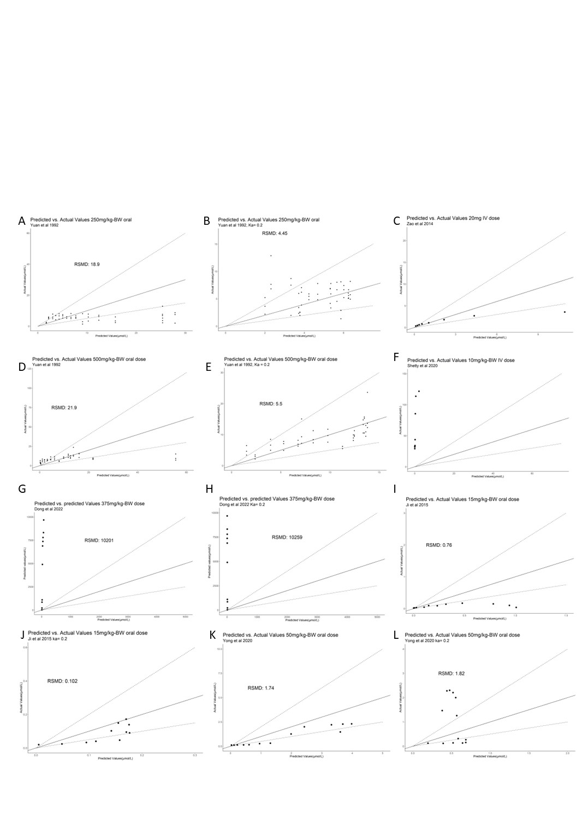 IE the higher the value the worse a model corresponds to the observed data. Adapting the model with a reduced Ka value improved model performance in 3 of the 5 cases with oral absorption and had a negligible or slight negative impact on the remaining two cases. With 500, 250, 20 and 15 mg/kg-BW doses most data points where within a 2 fold difference of the observed values. 50 mg/kg-BW values remained within a 5 fold difference and 15 mg/kg-BW doses within a 10 fold difference. 375 and 10 mg/kg-BW doses differed greatly from predicted values.

Figure : Predicted vs outcome plots of experimental data compared to the inhalation model in R. Plots (A,B,D,E,G,H,I, J, K, L) show oral data. Plots (C and F) show IV data. The diagonal solid lines in the graph represents the line at which predicted vs actual values are one 1. The dotted lines represent a 2 fold difference. To compare similar exposure the Root square mean deviation (RSMD) is added.

Table : Table showing the results of a 250 mg/kg-BW oral or inhalation exposure. Results of the single rat model (Green) different pharmacokinetic variables are shown. Results of the single Human model (Orange).Note the human and rat organ columns are not arranged the same.



## Interspecies comparison.

The Human model has no major changes to model structure that would lead to differences in simulation outcome compared to the rat model. The differences between the models is mainly in the specific input parameters concerning partition and physiological parameters. Table 1 shows the results of 4 simulations consisting of an oral and an inhalation exposure to both the single human and single rat model. When oral exposure is considered between human and rat simulation results a similar picture emerges. A very high AUC value for the primary exposed organ Small intestine followed by the Liver. The liver is directly linked to the small intestine in this model so this was expected. Followed by AUC values in the rest of the organs that are at least an order of magnitude lower. If we compare inhalation exposure between human and rat simulation results differ more compared to oral exposure. The organ with the highest Cmax and AUC value in rat is blood. In Humans this is Fat.

## Human model

In order evaluate the performance of the single and population based inhalation model only very limited metabolic data is available. In the study two male participants were given 0.7 mg/kg-BW CNMA orally. This resulted in 96.2% and 96.5% of the administered dose being excreted in the urine as hippuric acid, benzoyl glucuronide, HPPA or benzoyl acid al of which are downstream products of the Cinnamic acid metabolite(Maria & Peters, 1993) . In Figure 6 the results of 0.7 mg/kg-BW oral exposure simulation using the human population model can be seen. The median percentage metabolized for both females and males 97.6% after 24h. with 99.72% of results laying between 98.42% and 96.3%.

## 

## 

Figure : percentage of 0.7 mg/kg-BW oral dose metabolized to cinnamic acid metabolites using the Human population based model. Individual male and female results are represented as dots.

As no read across data of in vivo data was available no further validation steps were performed. In order to evaluate whether inhalation exposure leads to differences in sensitive organs two simulation where performed. In Figure 7 the results of these simulation can be seen. Populations where simulated as being exposed once to either a oral or inhalation dose of 250 mg/kg-BW. The concentrations of the various organs were then collected between 0 and 24 hours. Firstly as the simulations where ran with both a female and a male data set the results of these simulations were compared. Specifically, the mean values of these results were tested using Tukey HSD and a Welch T test. In all cases the male and female values differed significantly (P>0.05). With exception of the small intestine during oral exposures AUC values for females were higher then for males. If we consider the differences between exposure methods it can be observed that there are considerable differences. Mean CNMA AUC values for both males and females during inhalation exposure where higher in the following organs. Lung (252.6 fold), Blood(76.6 fold), Fat(126.6 fold), Slowly perfused tissue(318.8 fold) and Richly perfused tissue(284.5). Mean CNMA AUC values for both males and females were lower in the following organs; Liver(30.1 fold) and small intestine(75 fold). As a singular 250 mg/kg-BW inhalation dose is not representative of normal exposures during E-Cig usage repeat dosing of 2,8 mg/kg-BW as described in Exposure modeling was simulated. The results of this simulation are presented in Figure 8.

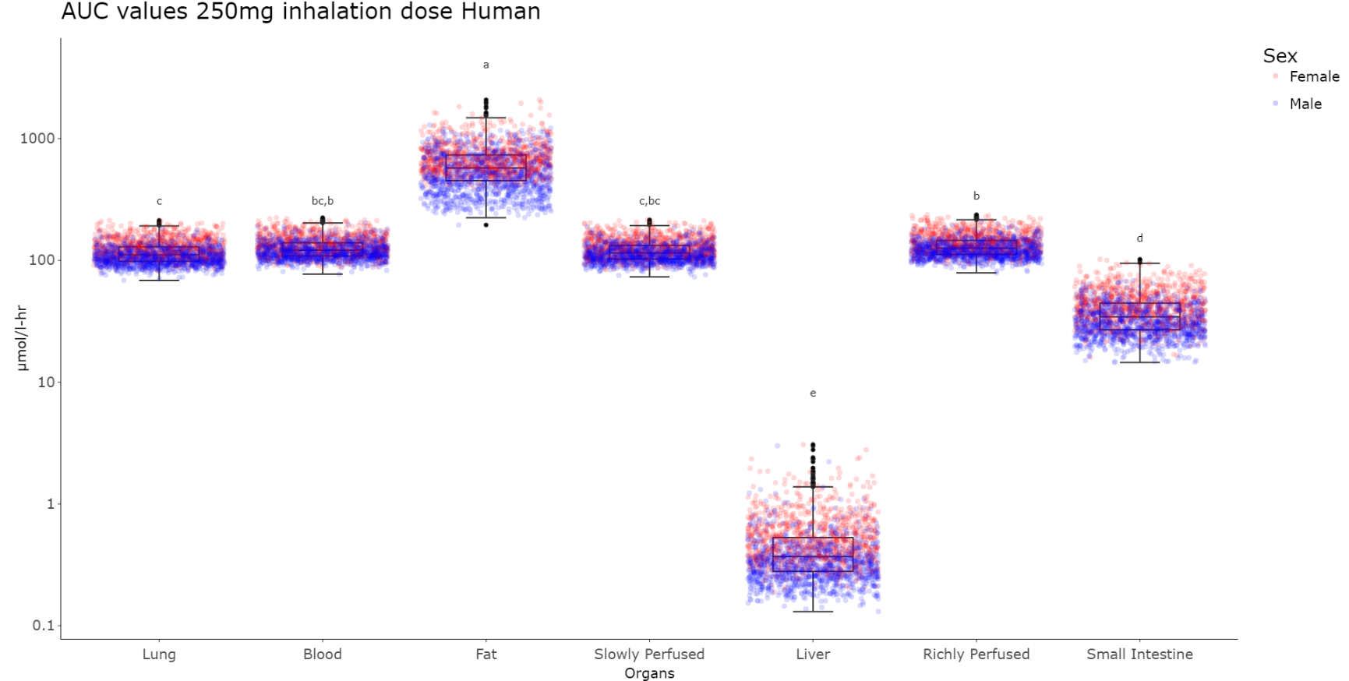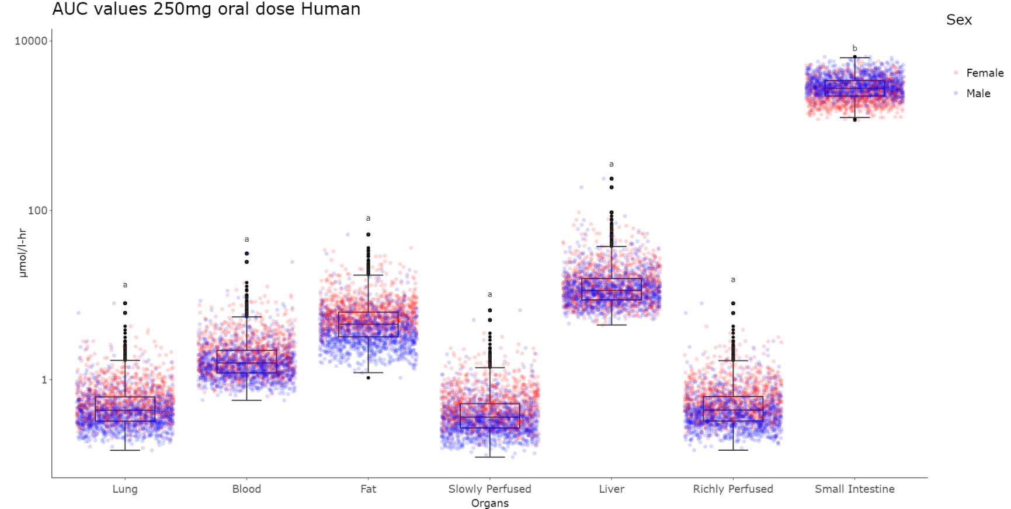

Figure : Area under the curve value results for a 250 mg/kg-BW and inhalation dose using the human inhalation population model. Significance differences were calculated between the different organs. Organs that do not differ significantly share the same significance letter. If two significancy letters are present the first one represents female results and the second male results. Inter-organs differences where tested using Tukey HSD tests (P>0.05). inter-sex differences where tested using both Tukey HSD test and Welch-t tests (P>0.05). In al organs there was a significant difference between male and female results

Similar steps were performed as before. Inter sex comparisons shown significant differences in the mean CNMA AUC values between females and males with higher values observed in female simulations. If compared to 250 mg/kg-BW exposures multiple exposures to 2.8 mg/kg-BW yielded the following results. CNMA AUC values were lower in all organs. Lung (4.5 fold), Blood(4.7 fold), Fat(2.2 fold), Slowly perfused tissue(5.12 fold), Richly perfused tissue(4.8), Liver(6.2) and Small Intestine(10.4 fold). The general distribution over organs was similar to 250 mg/kg-BW with the highest concentrations noted in fat. Cmax results can be found in Supplementary data 3: supplementary graphs.

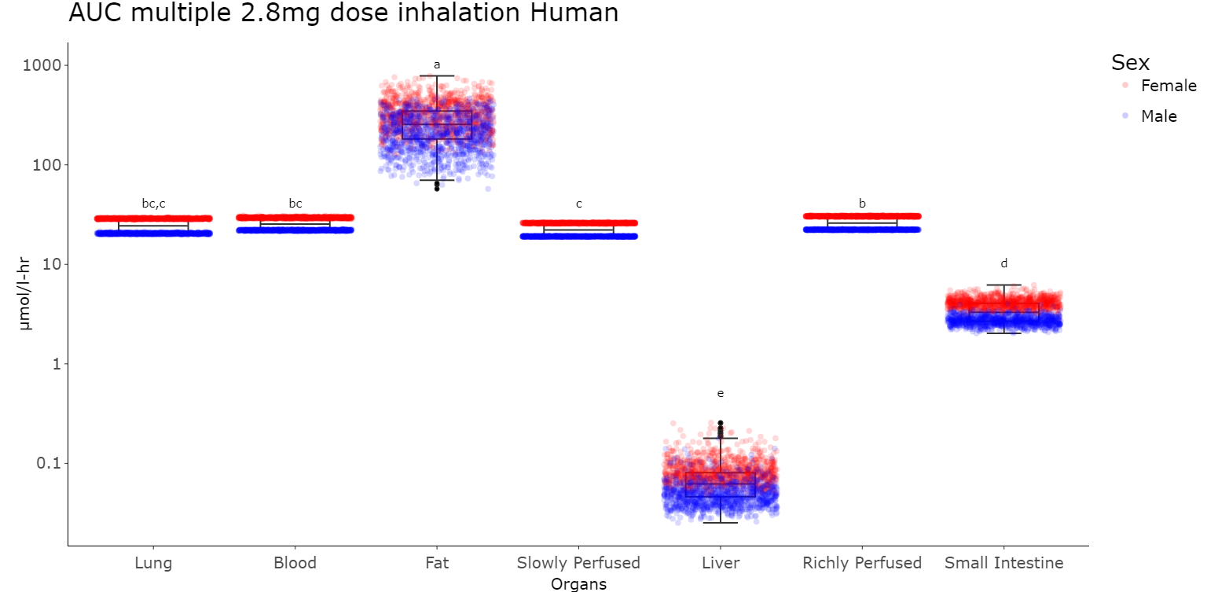

Figure : Area Under the Curve simulation results for Human population model based on multiple 2.8 mg/kg-BW inhalation exposures. Significance of differences were calculated between the different organs. Organs that do not differ significantly share the same significance letter. If two significancy letters are present the first one represents female results and the second male results. Inter-organs differences where tested using Tukey HSD tests (P>0.05). inter-sex differences where tested using both Tukey HSD test and Welch-t tests (P>0.05). For all organs there was a significant difference between males and female results.

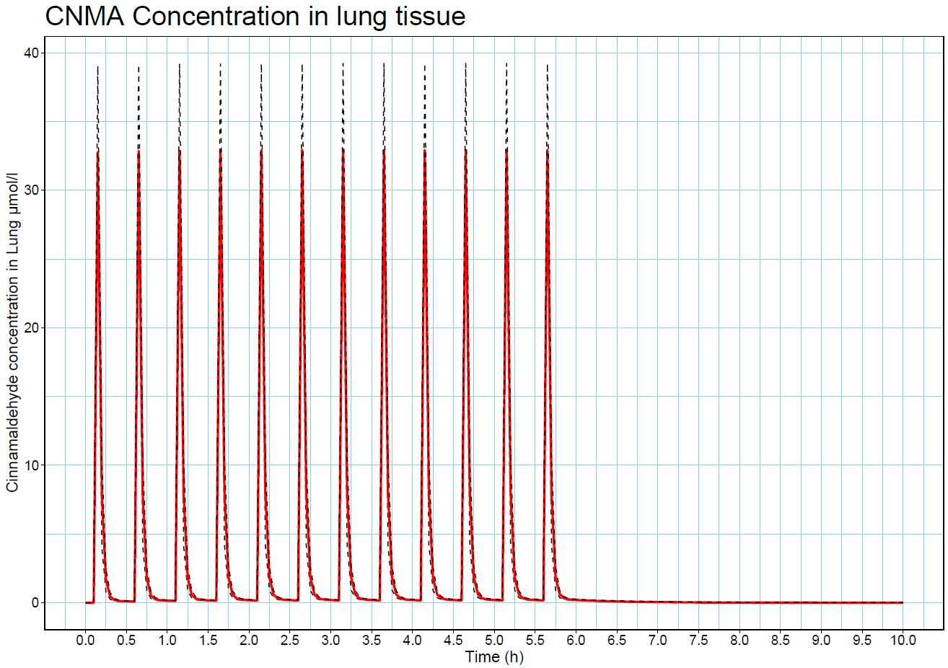In the context of exposure to E-Cig smoke the first organ to be exposed and the organ most associated with adverse effects of cigarette smoke is the lungs. Using the Human population based inhalation model the CNMA concentration in lung tissue was simulated after multiple exposures to 2.8 mg/kg-BW. The results of this simulation can be seen in Figure 9. After the start of exposure the CNMA concentration in the lung rapidly increases to a maximum of around 32 uM after which it rapidly decreases in about 30 min to zero. Inter individual variation in results are modest for the exposure peak the lower bound is 29.3 μmol/l, the mean is 32.8 μmol/l and the upper bound is 39.0 μmol/l. This variation is not evenly distributed between genders as can be seen in Figure 8 with female individuals CNMA concentrations being significantly higher than male individuals.

Figure : CNMA Lung tissue concentration after multiple 2.8 mg/kg-BW doses (Human population model. In red the mean concentration of CNMA in venous blood is represented the dotted lines represent the 95% confidence interval boundaries.

# Discussion

This report presents an human population inhalation model for exposure to CNMA. Population models allow a researcher to more accurately predict chemical concentrations in the general public. This is especially pertinent in the case CNMA as its use in E-Cig devices has not been comprehensively studied and thus in vivo data is still missing. This population model was based on real population data using the online tool Popgen. The pharmacokinetic parameters such as logKow and the partition coefficients were derived using QSAR’s.

Previously, a oral exposure model for CNMA was developed for rats and humans by Kiwamoto et al. This model was recapitulated in this report using the coding language R. The chemical specific parameters where calculated using relevant QSARs. Using the R code model and the newly calculated parameters this report was able generate oral absorption results to within 6 .5 fold of in vivo data See Figure 4. This represents a improvement compared to Kiwamoto *et al* as the general oral absorption model yielded results withing 56 fold of in vivo data. Kiwamoto *et al* generated results within a 6 fold difference only after the addition of a separate oral absorption model. For 500, 250, 20 and 15 mg/kg-BW doses most predicted data points where within a 2 fold difference compared to in vivo data. If a model predicts within 2 fold of in vivo data it is considered adequate for risk assessment (WHO, 2010). As noted by Kiwamoto *et al* significant differences between in vivo data source complicate overall characterization of model performance. The proposed mechanism of differences in sample preparation is unlikely to be the explanation for the 375 and 10 mg/kg-BW dosing differences as the model under estimates the CNMA concentration. Additionally (Shetty et al., 2020) found no appreciable CNMA degradation in samples at room temperature. As oral absorption predictions were not the focus of this report no further analysis was performed to explain these differences apart from the observation that heterogeneity in *in vivo* data is a complicated problem to solve. Furthermore, it was noted that reduction of the absorption rate constant further to 0.2 increased model fit in most cases. Fitting the absorption rate constant might work to improve model prediction yet it might not accurately represent CNMA dynamics in vivo as it is noted to be absorbed rapidly (Wu et al., 2022; Yingrong et al., 2009; Zhao et al., 2014). A possible explanation for high uptake rate is active transport into the gut. A Scopus search for CNMA AND transporter revealed no literature and CNMA was found not to be transported in Caco 2 cells (Wu et al., 2022). Lastly, in the model bioavailability is assumed to be 100% yet there is data suggesting this might be as low as 20% (Zhao et al., 2014). Therefore, more accurate simulation of bioavailability is a promising avenue for further improvement of the model.

One of the factors of rewriting the model in the R code is the possibility to perform a global sensitivity analysis (GSA). Is a preferable alternative to a Local sensitivity analysis as it is able to work with parameter sets which contain correlated parameters(Li et al., 2010; Liu et al., 2020). Yet, great difficulty’s were experienced in trying to implement a Sobol GSA approach during the writing of this report. The difficulty’s were of two general categories. Firstly, great computational demands for running GSA models with many input parameters. With 59 parameter inputs in the model running a GSA analysis demanded dozens of Gigabytes(GB) of Random access memory (RAM) and consumed up to 100 GB of storage per run. Secondly, GSA approaches are as of yet quite novel approach and therefor trouble shooting specific programming implementations was difficult. The GSA approach used in this report was as noted Sobol. This approach in its naïve form assumes non correlated inputs parameters. Another Sobol method has been developed to specifically deal with correlated parameters sets this method is called extended Sobol (Kucherenko et al., 2012). It is noted that this approach has been characterized as being so complicated that the usefulness is limited(Liu et al., 2020). Because of these considerations only a normal Sobol analysis was performed.

With relatively good performance in the rat oral model and agreement of the human model with the limited human metabolism data. The rat and human inhalation model was compared to results form the oral human and oral rat model. In the results it is clear that cinnamaldehyde appears to exhibits first pas metabolism. First pas metabolism is the phenomenon in which an orally taken chemical exhibits low systemic availability due to either poor absorption or fast metabolism(Doherty & Pang, 1997). As noted earlier absorption/bio availability is not modeled in these models so this effect is due to fast metabolism of CNMA in both rats and humans. In contrast to this the inhalation models do not exhibit this first pas effect and consequently have considerably higher AUC concentrations. The above mentioned effect is visible in both rats and human simulations. An difference between the simulations is the amount of CNMA that can be found in fat in comparison to other organs in human simulation results with inhalation AUC values being at least 10 fold higher that other organs. These differences are likely the results of a combination of two factors. Humans have considerably more adipose tissue in comparison to rats with 7% for rats and 21% for humans(Alexaklrin Obninsk et al., 2003). Added to this is that the predicted Fat:Blood Partition coefficient in Humans is 47.75 and 17.42 for Rats.

The difference between oral exposure and inhalation exposure were analyzed based on the simulation results shown in Figure 7 and Figure 8. As noted earlier the model predicts a clear first pas effect which ensures that CNMA concentration in the oral results are at least 75 fold lower than those seen in inhalation exposure simulation results. With the exception of liver and small intestine results as these are where higher in oral exposure scenario’s. This large difference in CNMA AUC values demonstrates the need to consider exposure pathways and the effects these can have on the target organ concentration. The most sensitive organ in inhalation exposure is predicted to be fat where a significant amount of CNMA is predicted to accumulate. CNMA is predicted to remain here for a significant time after 24h as can be seen in Table 1 specifically in the difference between AUC->end and AUC->inf. There were no gender differences in sensitive organs. A significant difference can be seen in all AUC values comparing males and females with inhalation exposure leading consistently to higher female AUC values. These differences are expected to be cause by differences in body composition such as higher fat percentage and smaller mean liver values see supplementary data for associated graphs. Multiple exposures to concentration relevant for E-Cig use did not change the overall distribution of CNMA but AUC values were between 2.2 and 10.4 fold lower. As lung are the main organ of interest for E-Cig exposures the concentration of CNMA was plotted to be able to compare it to in vitro data. This was done as CNMA has been noted to induce toxicity in different lung cells in vitro(Behar et al., 2014; Clapp et al., 2019; Ka et al., 2003). Furthermore, there is data suggesting immune suppressing effects of CNMA (Chapman et al., 2019; Clapp et al., 2017). The effective concentration in these studies differ from 49 uM to 10.000 uM. Ka *et al*  found the 49 uM IC50 value for LL3 mouse lung carcinoma cells. And Clapp *et al* 2017 and 2019 found IC50 values for Neutrophils, Macrophages and Natural killers cells ranging from 30 uM and 243 uM. If we compare this to predicted AUC->24h values using the population model which is a mean of around 30 μmol/l-hr. This would mean that worst case exposure E-cig exposure can lead to adverse immune effects due to the exposure of CNMA in E-Cigs. A limitation of this study is that Glutathione (GHS) is not modeled in the lungs. And, it is therefore possible that the GHS available in the lungs would reduce the available CNMA below levels predicted in this model.

In conclusion in this report a inhalation and population based CNMA model is presented. This model was then used to predict CNMA concentration after a worst case CNMA exposure as part of E-cig emission. This model predicts significant difference in CNMA concentrations in the body when comparing inhalation to oral exposure and predicts that these concentration differ significantly between males and females. When a worst case CNMA exposure is modeled the model predicts CNMA concentration in the lung which are associated with adverse effects in invitro systems. A major drawback of the model is lack of in vivo data available to validate model prediction for inhalation exposures. Promising future steps are generating in vivo data for CNMA or finding a suitable read across chemical to validate inhalation predictions. Adoption of the model for other aldehydes and the consideration of other chemicals associated with E-Cig emissions.

## Acknowledgments

I want to thank my supervisor N. Kramer for the support, guidance and flexibility during the project. I also want to thank S. Duarte Lopes Mascarenhas Proenca for the helpfully discussions concerning PBK modelling and R scripting.

Alexaklrin Obninsk, R., Boice Jr Rockville Cox Ditlcot, D. R., J Dicus, U. G., Streffer, D. C., Sugier, G. A., Lindell Stockholnt, B., B Meinhold Brookhut, S. C., Sinclair Escondido CA L S Taylor Mitchellville, W. K., Vienno, G., Beninson, A. D., Aires, B., Mettler Ir, F. A., Atgentina Sasaki, N. Y., & J Dunster, J. H. (2003). Annals of the ICRP Published on behalf of the lnternational Commission on Radiological Protection Annals Editor: J. VALENTIN, \CRP’ SE-l7l 16 Stockholm, Sweden International Commission on Radiological Protection 2001-2005 ICR] Basic Anatomi for IJse in I. In *Srt etien Scientific Secretary: Dr. J. Valentin*. http://www.elsevier.com

Behar, R. Z., Davis, B., Wang, Y., Bahl, V., Lin, S., & Talbot, P. (2014). Identification of toxicants in cinnamon-flavored electronic cigarette refill fluids. *Toxicology in Vitro*, *28*(2), 198–208. https://doi.org/10.1016/j.tiv.2013.10.006

Bertrand Iooss, A., da Veiga, S., Janon, A., Pujol, G., contribu-tions from Baptiste Broto, with, Boumhaout, K., Delage, T., el Amri, R., Fruth, J., Gilquin, L., Guillaume, J., Herin, M., il Idrissi, M., le Gratiet, L., Lemaitre, P., Marrel, A., Mey-naoui, A., Nelson, B. L., Monari, F., … Weber, F. (2022). *Package ‘sensitivity’ Title Global Sensitivity Analysis of Model Outputs*.

Bhattacharya, B., Narain, V., & Bondesson, M. (2021). E-cigarette vaping liquids and the flavoring chemical cinnamaldehyde perturb bone, cartilage and vascular development in zebrafish embryos. *Aquatic Toxicology*, *240*(September), 105995. https://doi.org/10.1016/j.aquatox.2021.105995

Brown, R. P., Delp, M. D., Lindstedt, S. L., Rhomberg, L. R., & Beliles, R. P. (1997). Physiological parameter values for physiologically based pharmacokinetic models. *Toxicology and Industrial Health*, *13*(4), 407–484. https://doi.org/10.1177/074823379701300401

Chapman, D. G., Casey, D. T., Ather, J. L., Aliyeva, M., Daphtary, N., Lahue, K. G., van der Velden, J. L., Janssen-Heininger, Y. M. W., & Irvin, C. G. (2019). The Effect of Flavored E-cigarettes on Murine Allergic Airways Disease. *Scientific Reports*, *9*(1). https://doi.org/10.1038/s41598-019-50223-y

Chatham-Stephens, K., Law, R., Taylor, E., Melstrom, P., Bunnell, R., Wang, B., Apelberg, B., & Schier, J. G. (2014). Calls to Poison Centers for Exposures to Electronic Cigarettes — United States, September 2010–February 2014. *Mortality Weekly Report*, *63*(13), 292–293. https://doi.org/10.2307/24854978

Clapp, P. W., Lavrich, K. S., van Heusden, C. A., Lazarowski, E. R., Carson, J. L., & Jaspers, I. (2019). Cinnamaldehyde in flavored e-cigarette liquids temporarily suppresses bronchial epithelial cell ciliary motility by dysregulation of mitochondrial function. *American Journal of Physiology - Lung Cellular and Molecular Physiology*, *316*(3), L470–L486. https://doi.org/10.1152/ajplung.00304.2018

Clapp, P. W., Pawlak, E. A., Lackey, J. T., Keating, J. E., Reeber, S. L., Glish, G. L., Jaspers, I., Pw, C., Ea, P., Jt, L., Je, K., & Sl, R. (2017). Flavored e-cigarette liquids and cinnamaldehyde impair respiratory innate immune cell function. *Am J Physiol Lung Cell Mol Physiol*, *313*, 278–292. https://doi.org/10.1152/ajplung.00452.2016.-Innate

Dejongh, J., Verhaar, H. J. M., & Hermens, J. L. M. (1997). *A quantitative property-property relationship (QPPR) approach to estimate in vitro tissue-blood partition coef®cients of organic chemicals in rats and humans*.

Doherty, M. M., & Pang, K. S. (1997). First-Pass Effect: Significance of the Intestine for Absorption and Metabolism. *Drug and Chemical Toxicology*, *20*(4), 329–344. https://doi.org/10.3109/01480549709003891

Dong, B., Chen, J., Cai, Y., Wu, W., & Chu, X. (2022). In vitro and in vivo evaluation of cinnamaldehyde Microemulsion–Mucus interaction. *Journal of Food Biochemistry*, *46*(10). https://doi.org/10.1111/jfbc.14307

Effah, F., Taiwo, B., Baines, D., Bailey, A., & Marczylo, T. (2022). Pulmonary effects of e-liquid flavors: a systematic review. In *Journal of Toxicology and Environmental Health - Part B: Critical Reviews* (Vol. 25, Issue 7, pp. 343–371). Taylor and Francis Ltd. https://doi.org/10.1080/10937404.2022.2124563

Fidler, M. L., Hallow, M., & Wang, W. (2022). *RxODE: Facilities for Simulating From ODE-Based Models*. Https://Nlmixrdevelopment.Github.Io/RxODE/Authors.Html. https://nlmixrdevelopment.github.io/RxODE/authors.html

Gerloff, J., Sundar, I. K., Freter, R., Sekera, E. R., Friedman, A. E., Robinson, R., Pagano, T., & Rahman, I. (2017). Inflammatory Response and Barrier Dysfunction by Different e-Cigarette Flavoring Chemicals Identified by Gas Chromatography–Mass Spectrometry in e-Liquids and e-Vapors on Human Lung Epithelial Cells and Fibroblasts. *Applied In Vitro Toxicology*, *3*(1), 28–40. https://doi.org/10.1089/aivt.2016.0030

Hallagan, J. B., & Hall, R. L. (2009). Under the conditions of intended use - New developments in the FEMA GRAS program and the safety assessment of flavor ingredients. In *Food and Chemical Toxicology* (Vol. 47, Issue 2, pp. 267–278). https://doi.org/10.1016/j.fct.2008.11.011

Hartmann-Boyce, J., McRobbie, H., Butler, A. R., Lindson, N., Bullen, C., Begh, R., Theodoulou, A., Notley, C., Rigotti, N. A., Turner, T., Fanshawe, T. R., & Hajek, P. (2021). Electronic cigarettes for smoking cessation. *Cochrane Database of Systematic Reviews*, *2022*(8). https://doi.org/10.1002/14651858.CD010216.pub6

Hua, M., & Talbot, P. (2016). Potential health effects of electronic cigarettes: A systematic review of case reports. In *Preventive Medicine Reports* (Vol. 4, pp. 169–178). Elsevier Inc. https://doi.org/10.1016/j.pmedr.2016.06.002

IARC Working Group on the Evaluation of Carcinogenic Risks to Humans., World Health Organization., & International Agency for Research on Cancer. (2006). *Formaldehyde, 2-Butoxyethanol and 1-tert-Butoxypropan-2-ol.* International Agency for Research on Cancer.

IARC Working Group on the Evaluation of Carcinogenic Risks to Humans.World Health Organization.International Agency for Research on Cancer. (2021). *ACROLEIN, CROTONALDEHYDE, AND ARECOLINE VOLUME 128 IARC MONOGRAPHS ON THE IDENTIFICATION OF CARCINOGENIC HAZARDS TO HUMANS*. https://publications.iarc.fr/602

Ji, B., Zhao, Y., Zhang, Q., Wang, P., Guan, J., Rong, R., & Yu, Z. (2015). Simultaneous determination of cinnamaldehyde, cinnamic acid, and 2-methoxy cinnamic acid in rat whole blood after oral administration of volatile oil of Cinnamoni Ramulus by UHPLC-MS/MS: An application for a pharmacokinetic study. *Journal of Chromatography B: Analytical Technologies in the Biomedical and Life Sciences*, *1001*, 107–113. https://doi.org/10.1016/j.jchromb.2015.07.049

Jongeneelen, F. J., & Berge, W. F. T. (2011a). A generic, cross-chemical predictive PBTK model with multiple entry routes running as application in MS Excel; design of the model and comparison of predictions with experimental results. *Annals of Occupational Hygiene*, *55*(8), 841–864. https://doi.org/10.1093/annhyg/mer075

Jongeneelen, F. J., & Berge, W. F. T. (2011b). A generic, cross-chemical predictive PBTK model with multiple entry routes running as application in MS Excel; design of the model and comparison of predictions with experimental results. *Annals of Occupational Hygiene*, *55*(8), 841–864. https://doi.org/10.1093/annhyg/mer075

Ka, H., Park, H. J., Jung, H. J., Choi, J. W., Cho, K. S., Ha, J., & Lee, K. T. (2003). Cinnamaldehyde induces apoptosis by ROS-mediated mitochondrial permeability transition in human promyelocytic leukemia HL-60 cells. *Cancer Letters*, *196*(2), 143–152. https://doi.org/10.1016/S0304-3835(03)00238-6

Kasteel, E. E. J., Lautz, L. S., Culot, M., Kramer, N. I., & Zwartsen, A. (2021). Application of in vitro data in physiologically-based kinetic models for quantitative in vitro-in vivo extrapolation: A case-study for baclofen. *Toxicology in Vitro*, *76*. https://doi.org/10.1016/j.tiv.2021.105223

Khachatoorian, C., McWhirter, K. J., Luo, W., Pankow, J. F., & Talbot, P. (2022). Tracing the movement of electronic cigarette flavor chemicals and nicotine from refill fluids to aerosol, lungs, exhale, and the environment. *Chemosphere*, *286*, 131494. https://doi.org/10.1016/j.chemosphere.2021.131494

Kiwamoto, R., Ploeg, D., Rietjens, I. M. C. M., & Punt, A. (2016). Dose-dependent DNA adduct formation by cinnamaldehyde and other food-borne α,β-unsaturated aldehydes predicted by physiologically based in silico modelling. *Toxicology in Vitro*, *31*, 114–125. https://doi.org/10.1016/j.tiv.2015.11.014

Kucherenko, S., Tarantola, S., & Annoni, P. (2012). Estimation of global sensitivity indices for models with dependent variables. *Computer Physics Communications*, *183*(4), 937–946. https://doi.org/10.1016/j.cpc.2011.12.020

Li, G., Rabitz, H., Yelvington, P. E., Oluwole, O. O., Bacon, F., Kolb, C. E., & Schoendorf, J. (2010). Global sensitivity analysis for systems with independent and/or correlated inputs. *Journal of Physical Chemistry A*, *114*(19), 6022–6032. https://doi.org/10.1021/jp9096919

Liu, D., Li, L., Rostami-Hodjegan, A., Bois, F. Y., & Jamei, M. (2020). Considerations and Caveats when Applying Global Sensitivity Analysis Methods to Physiologically Based Pharmacokinetic Models. *AAPS Journal*, *22*(5). https://doi.org/10.1208/s12248-020-00480-x

Lopachin, R. M., & Gavin, T. (2014). Molecular mechanisms of aldehyde toxicity: A chemical perspective. In *Chemical Research in Toxicology* (Vol. 27, Issue 7, pp. 1081–1091). American Chemical Society. https://doi.org/10.1021/tx5001046

Maria, M., & Peters, C. G. (1993). *Metabolic and Mechanistic Studies in the Safety Evaluation of frans-Cinnamaldehyde*.

Muthumalage, T., Prinz, M., Ansah, K. O., Gerloff, J., Sundar, I. K., & Rahman, I. (2018). Inflammatory and oxidative responses induced by exposure to commonly used e-cigarette flavoring chemicals and flavored e-liquids without nicotine. *Frontiers in Physiology*, *8*(JAN). https://doi.org/10.3389/fphys.2017.01130

Omaiye, E. E., McWhirter, K. J., Luo, W., Tierney, P. A., Pankow, J. F., & Talbot, P. (2019). High concentrations of flavor chemicals are present in electronic cigarette refill fluids. *Scientific Reports*, *9*(1). https://doi.org/10.1038/s41598-019-39550-2

Page, M. K., & Goniewicz, M. L. (2021). New Analytical Method for Quantifying Flavoring Chemicals of Potential Respiratory Health Risk Concerns in e-Cigarette Liquids. *Frontiers in Chemistry*, *9*. https://doi.org/10.3389/fchem.2021.763940

Price, P. S., Conolly, R. B., Chaisson, C. F., Gross, E. A., Young, J. S., Mathis, E. T., & Tedder, D. R. (2003). Modeling Interindividual Variation in Physiological Factors Used in PBPK Models of Humans. In *Critical Reviews in Toxicology* (Vol. 33, Issue 5, pp. 469–503). CRC Press LLC. https://doi.org/10.1080/10408440390242324

Shetty, V., Chellampillai, B., & Kaul-Ghanekar, R. (2020). Development and validation of a bioanalytical HPLC method for simultaneous estimation of cinnamaldehyde and cinnamic acid in rat plasma: Application for pharmacokinetic studies. *New Journal of Chemistry*, *44*(11), 4346–4352. https://doi.org/10.1039/c9nj03183a

WHO. (2010). *CHARACTERIZATION AND APPLICATION OF PHYSIOLOGICALLY BASED PHARMACOKINETIC MODELS IN RISK ASSESSMENT*.

*WHO global report on trends in prevalence of tobacco use 2000-2025 Fourth edition WHO global report on trends in prevalence of tobacco use 2000-2025, fourth edition ISBN 978-92-4-003932-2 (electronic version)*. (2021). http://apps.who.int/bookorders.

Willmann, S., Höhn, K., Edginton, A., Sevestre, M., Solodenko, J., Weiss, W., Lippert, J., & Schmitt, W. (2007). Development of a physiology-based whole-body population model for assessing the influence of individual variability on the pharmacokinetics of drugs. *Journal of Pharmacokinetics and Pharmacodynamics*, *34*(3), 401–431. https://doi.org/10.1007/s10928-007-9053-5

Wu, L., Meng, Y., Xu, Y., & Chu, X. (2022). Improved uptake and bioavailability of cinnamaldehyde via solid lipid nanoparticles for oral delivery. *Pharmaceutical Development and Technology*, 1–33. https://doi.org/10.1080/10837450.2022.2147542

Yingrong, C. I., Ma, Y., & Mal, W. (2009). Pharmacokinetics and bioavailability of cinnamic acid after oral administration of ramulus cinnamomi in rats. In *EUROPEAN JOURNAL OF DRUG METABOLISM AND PHARMACOKINETICS* (Vol. 34, Issue I).

Yong, Z., Xingqi, W., Jie, H., Rongfeng, H., & Xiaoqin, C. (2020). Formulation, production, in vitro release and in vivo pharmacokinetics of cinnamaldehyde sub-micron emulsions. *Pharmaceutical Development and Technology*, *25*(6), 676–685. https://doi.org/10.1080/10837450.2020.1729800

Yu, L. X., & Amidon, G. L. (1999). A compartmental absorption and transit model for estimating oral drug absorption. In *International Journal of Pharmaceutics* (Vol. 186). www.elsevier.com/locate/promis

Yuan, J. H., Dieter, M. P., Buctter, J. R., & Jameson, C. W. (1992). TOXICOKINETICS OF CINNAMALDEHYDE IN F344 RATS. In *Fd Chem. Toxic* (Vol. 30, Issue 12).

Zhao, H., Xie, Y., Yang, Q., Cao, Y., Tu, H., Cao, W., & Wang, S. (2014). Pharmacokinetic study of cinnamaldehyde in rats by GC-MS after oral and intravenous administration. *Journal of Pharmaceutical and Biomedical Analysis*, *89*, 150–157. https://doi.org/10.1016/j.jpba.2013.10.044